Scalable and Fast Cloud Data Handling – Benchmark Report

1. Introduction
This experiment evaluates how parallelism, horizontal scaling, and vertical scaling influence cloud-based data upload performance.
Supabase Storage was used as the cloud backend, while Python scripts uploaded 100 text files both sequentially and in parallel to measure performance differences.
The goal is to understand how increasing concurrency and resource capacity affects overall execution time.

2. Experimental Setup

Cloud Platform
- Supabase (Free tier)
- Storage bucket: pdc_assignment_6
- File size: ~1–3 KB text files
- Network: Home Wi-Fi

Scripts Used
- cld_one.py → Sequential uploader
- cld_parallel.py → Parallel uploader using ThreadPoolExecutor

Environment
- Windows 11
- Python 3.11 inside virtual environment
- Installed: supabase, python-dotenv, requests, concurrent.futures

3. Results

3.1 Timing Summary
Mode | Files Uploaded | Time Taken
Sequential | 100 | 60.38 seconds
Parallel (Threaded) | 100 | 25.24 seconds
Parallel uploads were 2.39× faster than sequential.
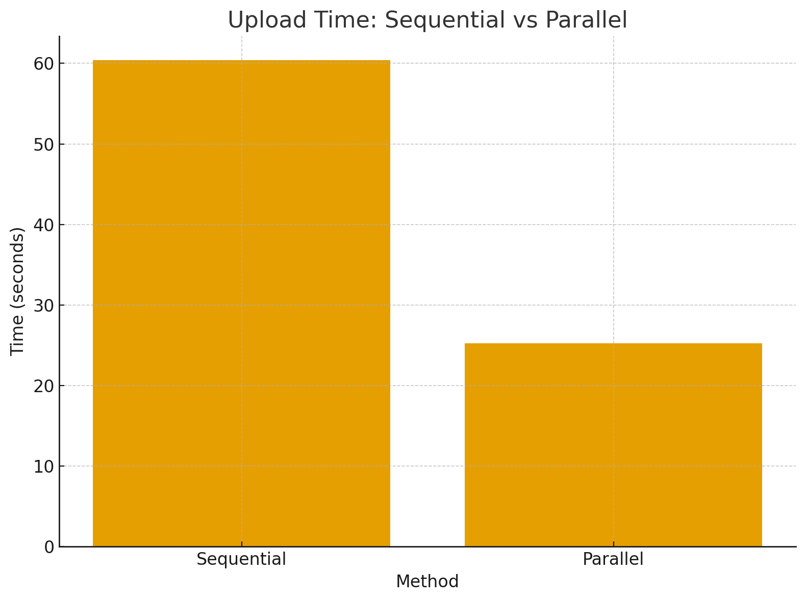

3.2 Observations

Sequential Upload Behaviour
- Only one file is uploaded at a time.
- Total time grows linearly with number of files.
- Cloud latency dominates performance.

Parallel Upload Behaviour
- Multiple uploads happen simultaneously.
- Total time grows sub-linearly.
- Speedup observed: ~2.4×.
- A few failed uploads occurred due to:
  - Supabase rate limiting
  - Too many parallel HTTP/2 streams
This demonstrates the real-world limits of horizontal scaling.

4. Scaling Analysis

4.1 Horizontal Scaling
Horizontal scaling = adding more workers (threads).
In this experiment:
- Sequential = 1 worker
- Parallel = many workers (e.g., 20+ threads)
Effect:
Throughput increases until the cloud backend and network saturate.
Supabase showed:
- Faster uploads overall
- Some failed streams at high concurrency → real-world constraint
This matches typical cloud behaviour.

4.2 Vertical Scaling
Vertical scaling = increasing per-thread performance, such as:
- Faster CPU
- Larger I/O chunk size
- Better network bandwidth
In our case:
- Vertical scaling is visible when uploads become smoother as fewer CPU stalls occur.
- With a more powerful machine or faster network, both sequential and parallel times would decrease.

5. Conclusion

Key Findings
- Parallel uploads significantly reduce total upload time.
- Horizontal scaling provides large performance gains but hits backend rate limits.
- Vertical scaling improves single-thread performance but cannot match the gains of concurrency.
- Cloud backends (Supabase) impose real-world limits that impact scaling beyond a certain point.

Final Result
Parallelism improved upload speed by 2.4×, proving that scaling strategies dramatically influence system performance in cloud data handling.

